**Name: Varshni Soundarya R**

**Register number: 1919103135**

**College: Sona College of Technology**

**Date: 13.09.2022**

**ASSIGNMENT - 1**

**CIRCUIT CONNECTION:**

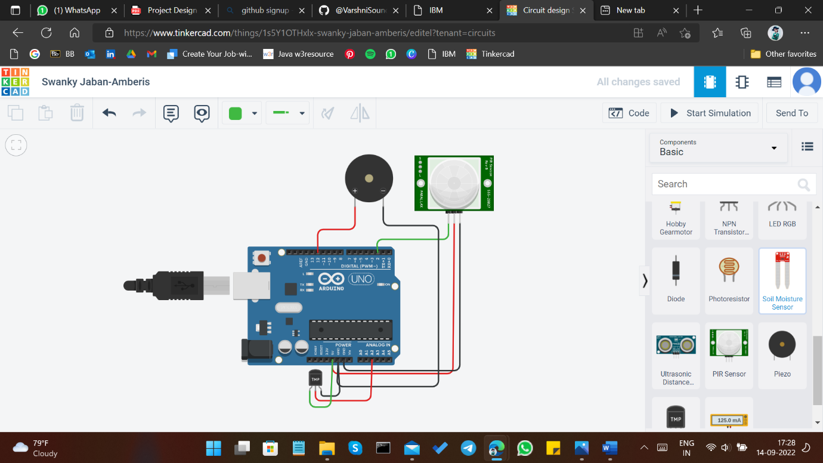

**PROGRAM:**

void setup(){

Serial.begin(9600);

pinMode(2,INPUT);

}

void loop(){

int motion=digitalRead(2);

double data=analogRead(A2);

double n=data/1024;

double volt=n*5;

double off=volt-0.5;

double temp=off*100;

if(temp>60){

Serial.println("Temperature is greater than 60");

tone(12,200);

delay(2000);

}

if(motion == 1){

Serial.println("Motion is detected");

tone(12,100);

delay(2000);

}

}

**OUTPUT:**

